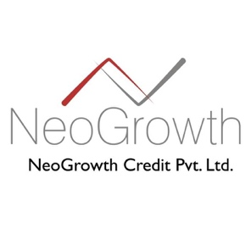

If you are looking for a business loan for any of your business needs, opt for NeoGrowth Credit Pvt. Ltd. The hassle free procedure involves doorstep documentation and the use of modern technology. So, you need not worry about the flow of funds. NeoGrowth offers business loan not on the basis of the financial statements, but on the stability and performance of your business and the cash flow estimation. And, for repayment, you can choose to pay more when your business is flourishing or less when the sales have dipped. This ensures that you pay more attention to your business.

For more information refer NeoGrowth business loans site:
https://www.neogrowth.in/applyNow/

